**Signals and Systems Final Project**

**(Matlab)**

**Part 1**

**Name:** Ahmed Wael Mohamed

**ID:** 6071

**Question 1**

**Handwritten Analysis**

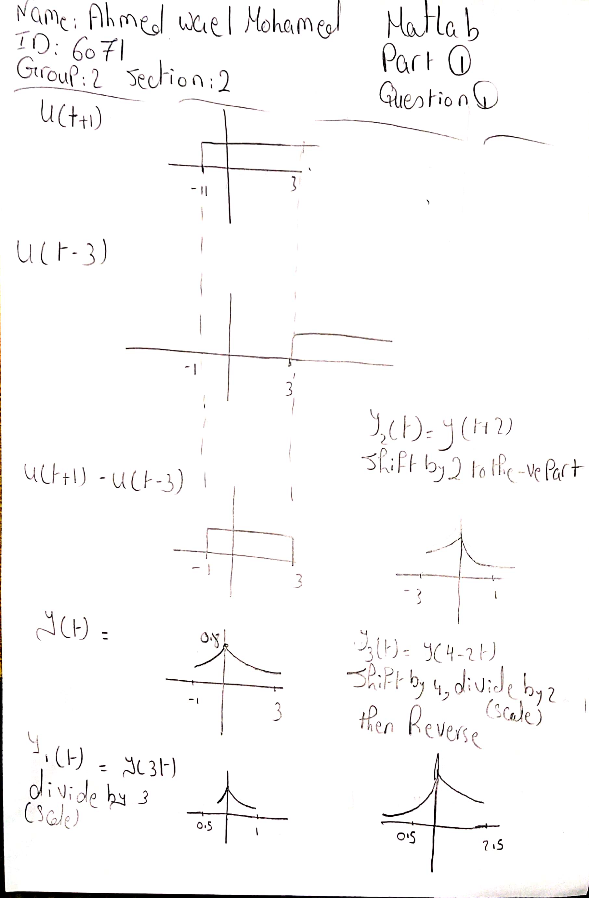

**Source Code**

t = linspace(-1, 3, 2000);

X = exp(-1/5 * abs(t));

subplot (2,2,1);

plot (t,X);

title ( ' Y(t) ');

subplot (2,2,2);

plot (t/3,X);

title ( ' Y1(t) ');

subplot (2,2,3);

plot (t - 2,X);

title ( ' Y2(t) ');

subplot (2,2,4);

plot ((-t/2) + 2,X);

title ( ' Y3(t) ');

**Figures**

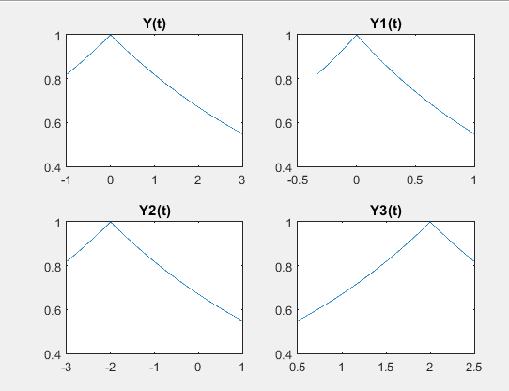

**Question 2**

**Handwritten Analysis**

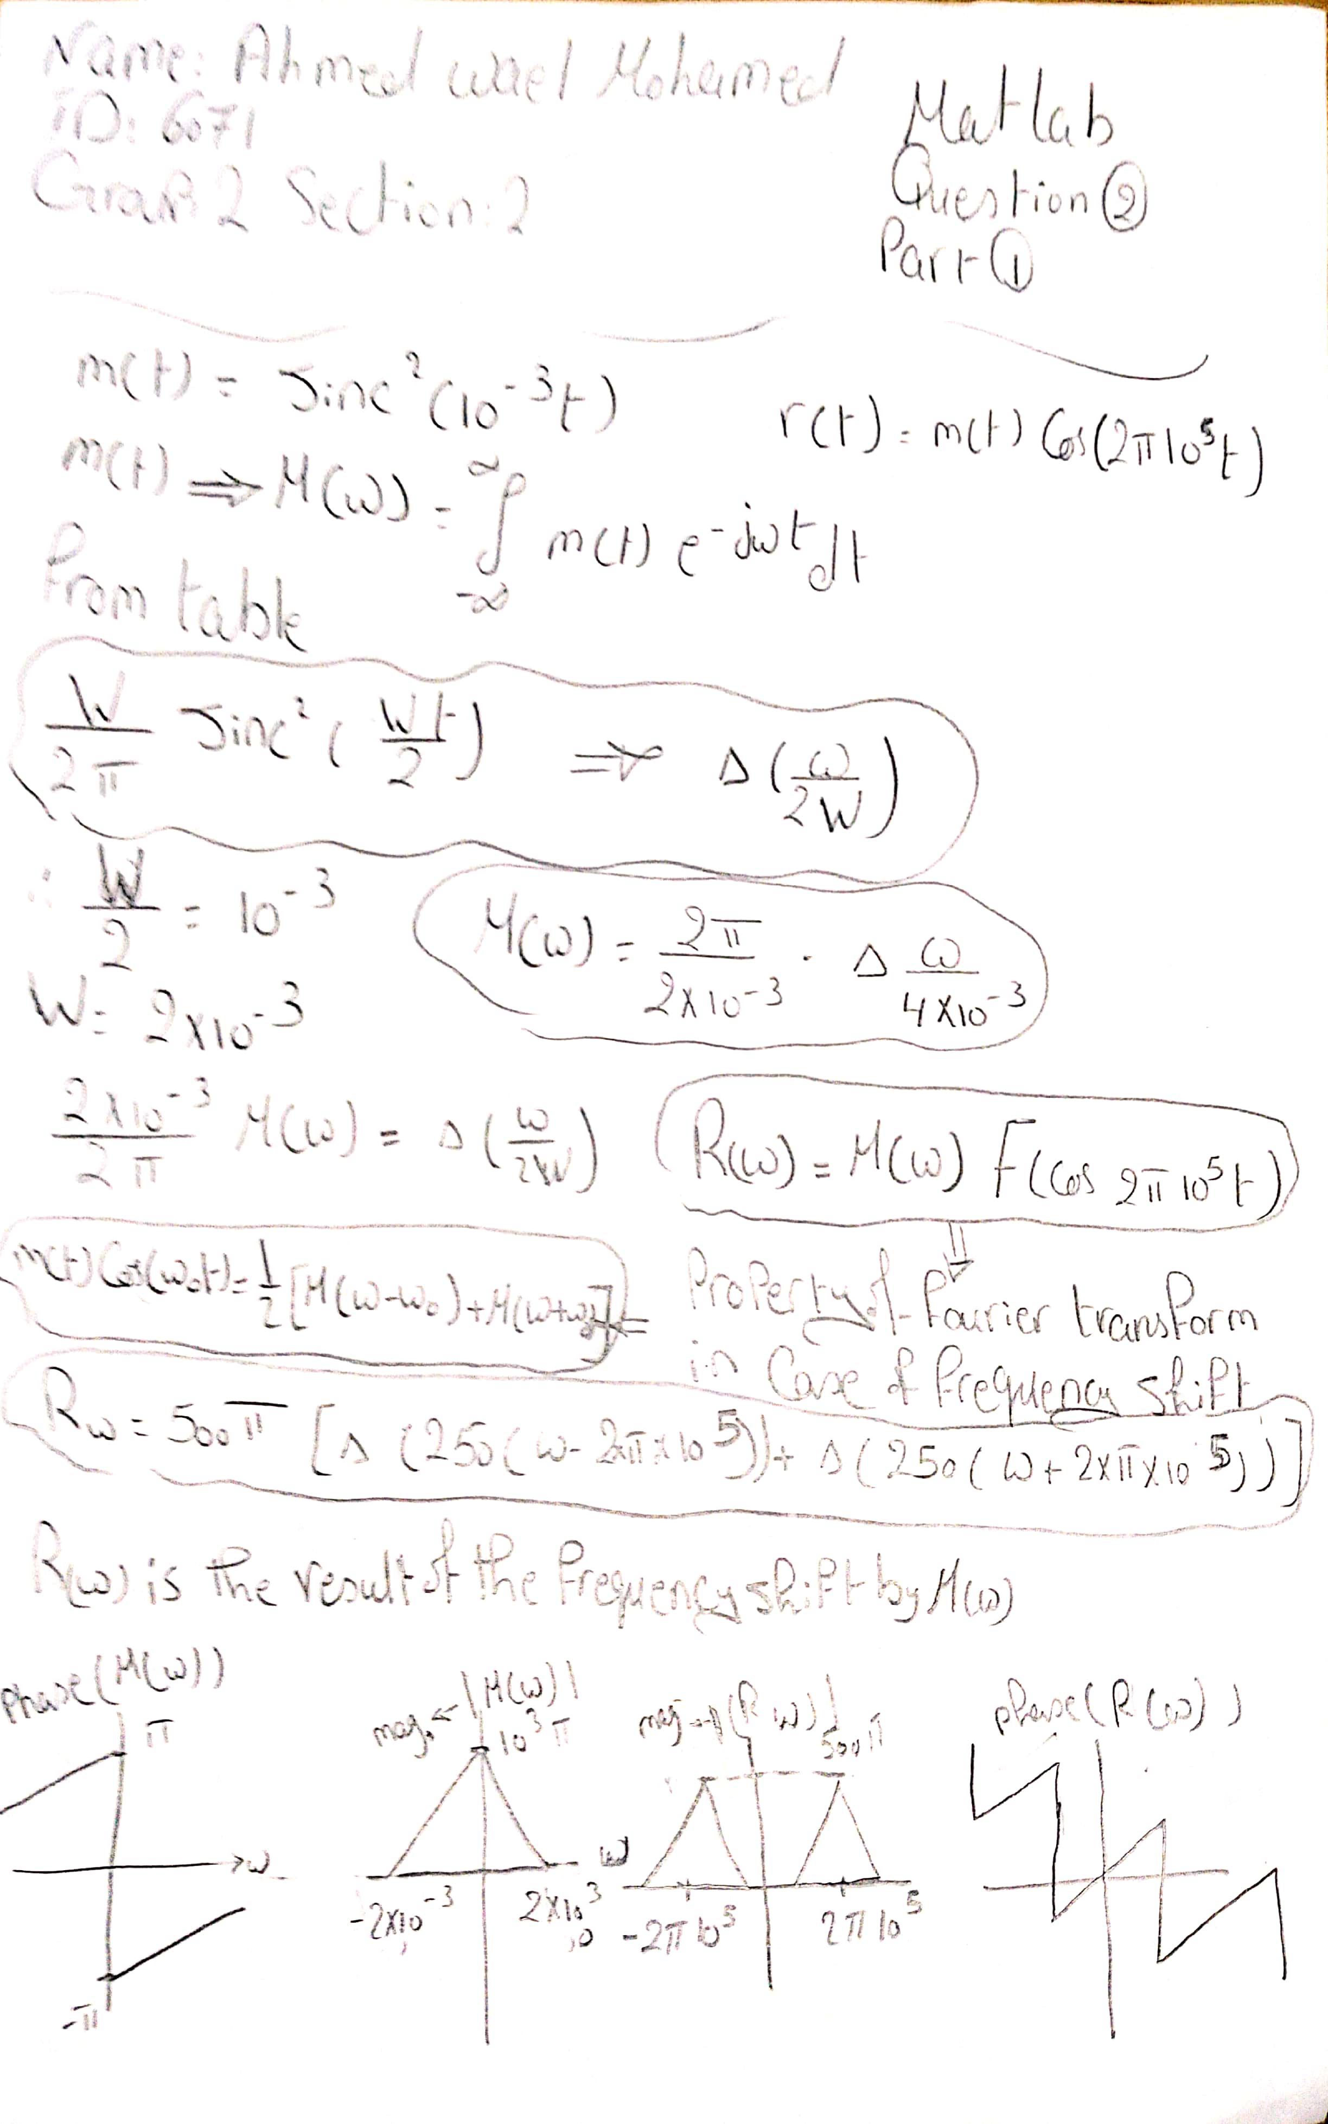

**Source Code**

t = linspace(-0.5,0.5,100)

m = (sinc(10.^(-3) * t)).^2;

figure;

plot(t,m)

title ( ' m(t) ' );

M = fftshift(fft(m));

Fvec = linspace (-50,50,100);

figure;

plot(Fvec,M)

title ( ' M(w) ' );

Mmag = abs(M);

figure

plot (Fvec,Mmag);

title ( ' Magnitude of M(w) ' );

Mphase = angle (M);

figure;

plot (Fvec,Mphase);

title ( ' Phase of M(w) ' );

r = cos(2*pi*10.^5*t) .* m;

figure;

plot(t,r)

title( ' r(t) ' );

R = fftshift(fft(r));

figure;

plot(Fvec,R)

title( ' R(w) ' );

Rmag = abs(R);

figure;

plot(Fvec,Rmag)

title ( ' Magnitude of R(w) ' );

Rphase = angle(R);

figure;

plot(Fvec,Rphase);

title ( ' Phase of R(w) ' );

**Figures**

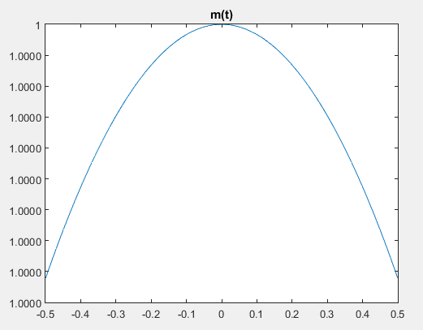

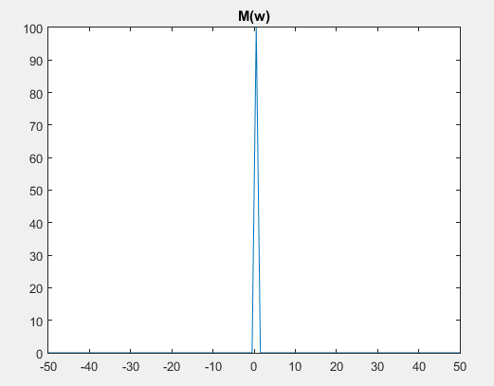

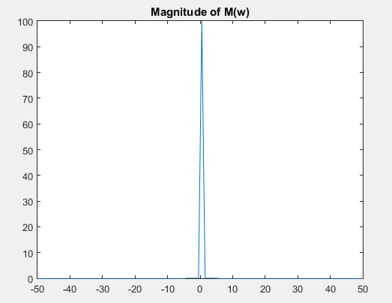

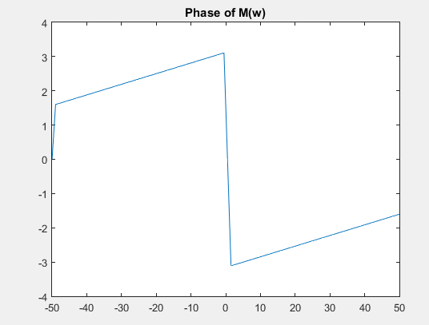

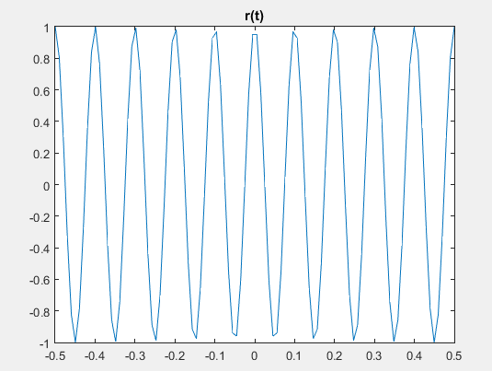

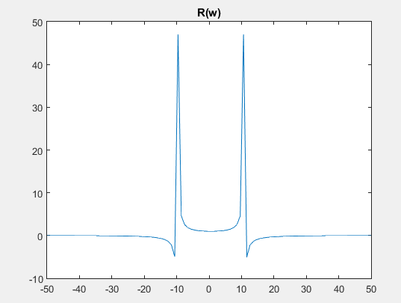

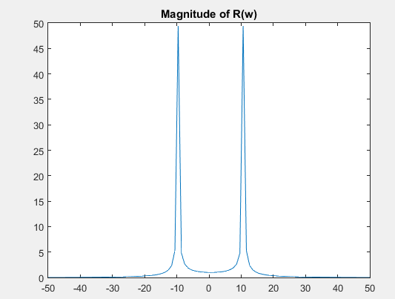

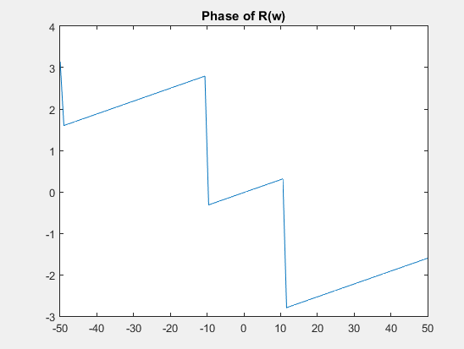

**Question 3**

**Handwritten Analysis**



**Source Code**

nneg = -10:-1;

npos = 1:10;

Fnneg = (1./(pi*(1+(2*1i*nneg)))).*(1-exp(-pi*(1+1i*2*nneg)));

Fnpos = (1./(pi*(1+(2*1i*npos)))).*(1-exp(-pi*(1+1i*2*npos)));

F0 = 0.305;

Fn = [Fnneg F0 Fnpos];

n = [nneg 0 npos];

figure;

stem(n, abs(Fn))

title( ' Magnitude Spectrum ' );

figure;

stem(n, angle(Fn))

title ( ' Phase Spectrum ' );

**Figures**

